**PROJECT REPORT**

**TOPIC: DIGITAL THERMOMETER USING LM35**

**ABSTRACT:**

Thermometers are widely used to measure temperature of human body and it is a commonly used device nowadays. This project involves a simple working of digital thermometer by using LM35 sensor. Future work of this project involves advancing by including sensors like DHT11/22 which gives humidity values which can be used in agricultural automations like measuring soil moisture, humidity, etc.,

**COMPONENTS USED:**

* Atmega328p
* LM35 sensor
* Lcd display (Hd44780)

**ATMEGA328P :**

* The ATmega328 is a single-[chip](https://en.wikipedia.org/wiki/Integrated_circuit) [microcontroller](https://en.wikipedia.org/wiki/Microcontroller) created by [Atmel](https://en.wikipedia.org/wiki/Atmel) in the [megaAVR](https://en.wikipedia.org/wiki/MegaAVR) .
* It has a modified Harvard architecture [8-bit](https://en.wikipedia.org/wiki/8-bit) [RISC](https://en.wikipedia.org/wiki/Reduced_instruction_set_computer) processor core.

**LM35 SENSOR:**

The LM35 is one kind of commonly used temperature sensor that can be used to measure temperature with an electrical o/p comparative to the temperature (in °C). It can measure temperature more correctly compare with a thermistor.

**LCD DISPLAY (HD44780):**

A 16x2 LCD means it can display 16 characters per line and there are 2 such lines. In this LCD each character is displayed in 5x7 pixel matrix. The 16 x 2 intelligent alphanumeric dot matrix display is capable of displaying 224 different characters and symbols.

**SOFTWARE USED:**

* Simulide
* Visual Studio Code

**BLOCK DIAGRAM:**

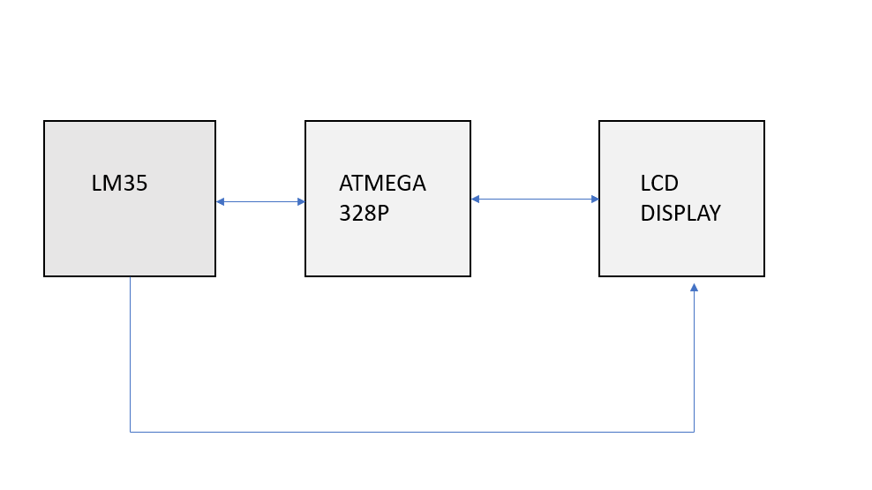**WORKING:**

* Here a mimic model of LM35 is used to measure the temperature.
* When the circuit is ON the display shows the name of the person which is passed in the form of string and the temperature is displayed.
* Only partial output is derived.

**OUTPUT:**

